Playwright TESTING
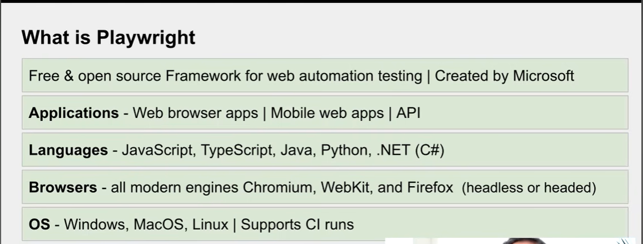

Features of playwright
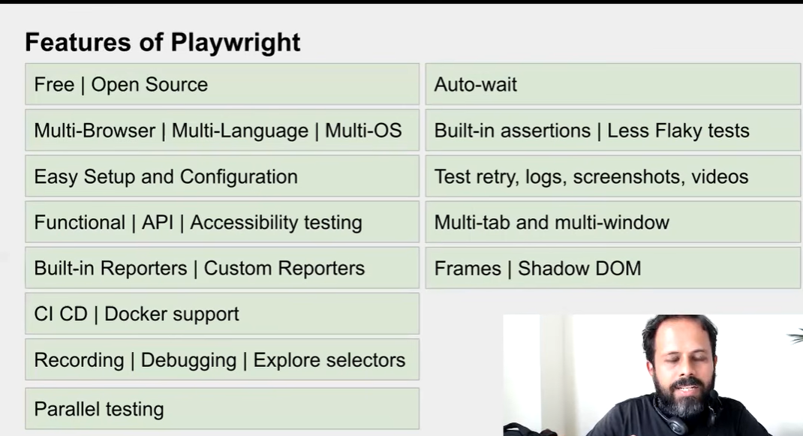
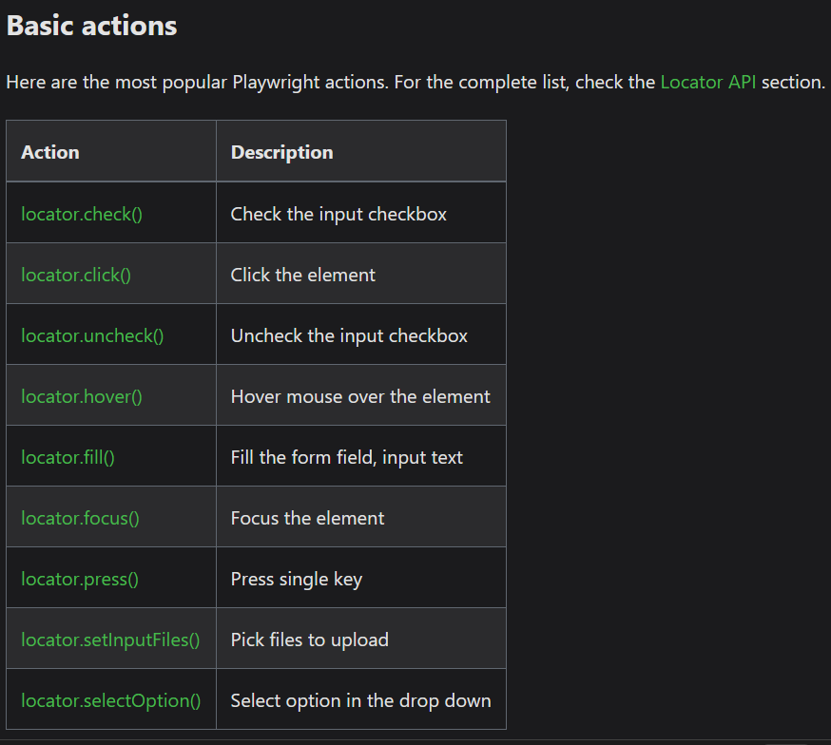

Language for the Playwright
java,python,TS and JS

IDE
integrated development envir
Run command
npx playwright test

Server comments
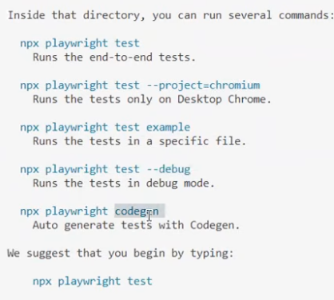
Project structure
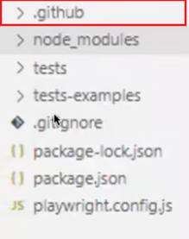

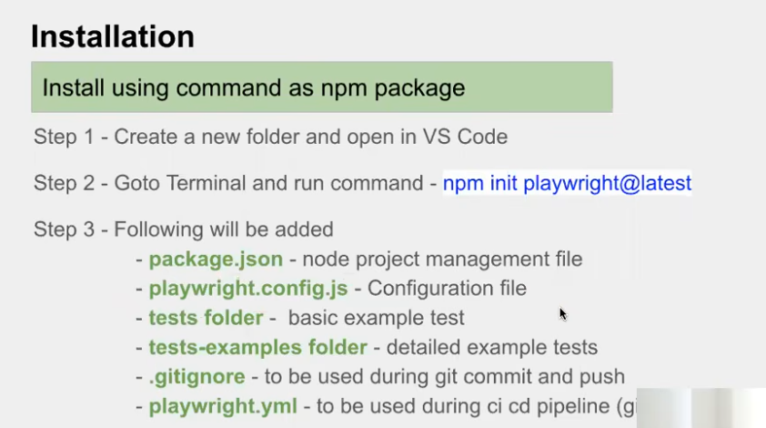
For execution
npx

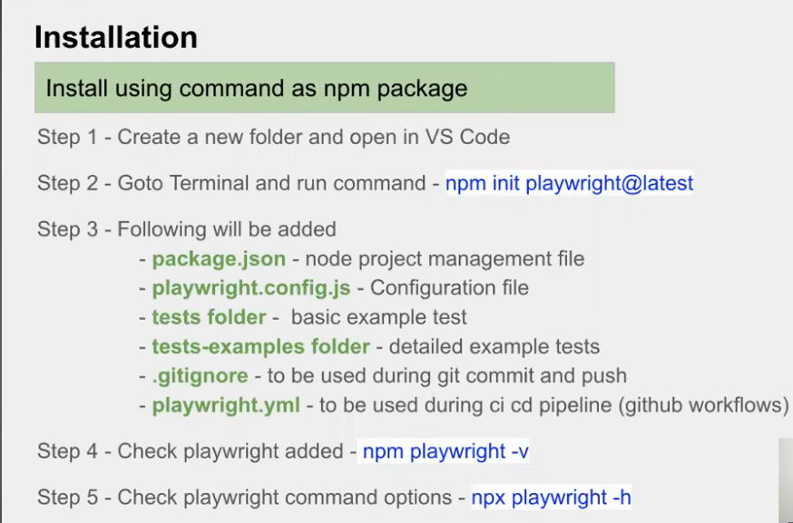
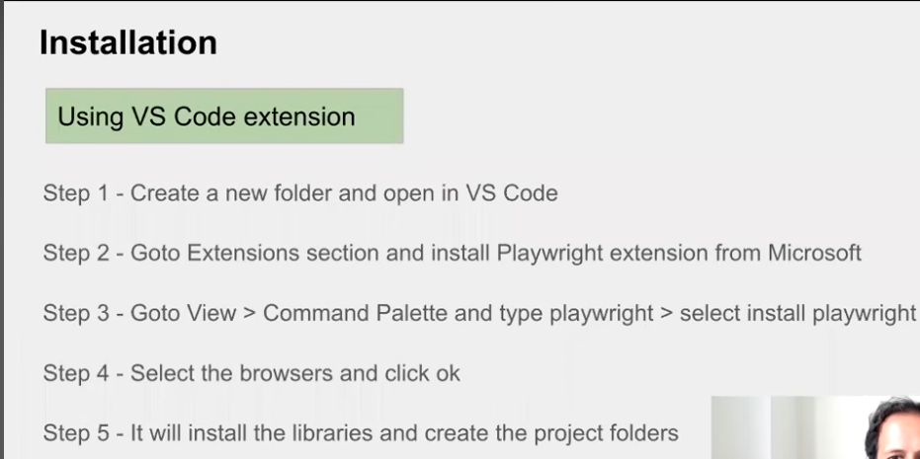
Types of command running
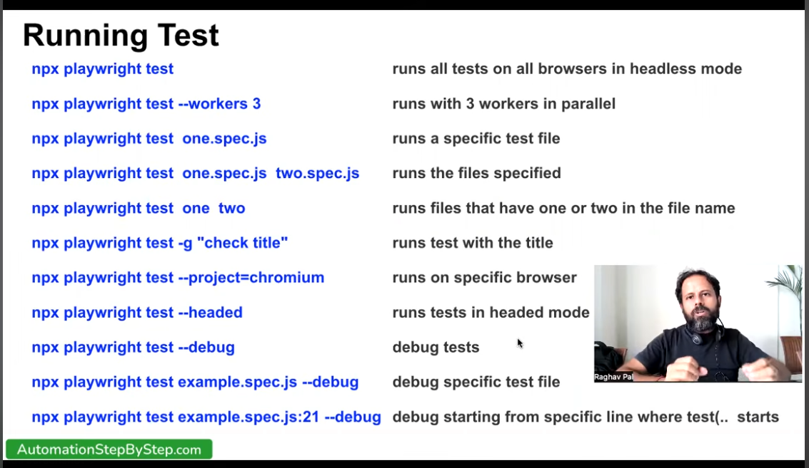

Step for creating the test
- Create a test file under the folder
- Filename.spec.js
- Include the playwright modules
- Const {test,expect} = Require (‘@playwright/folder’)
- 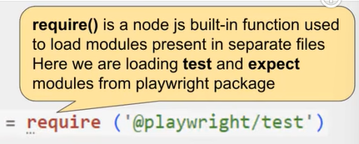
- Test block creating
- 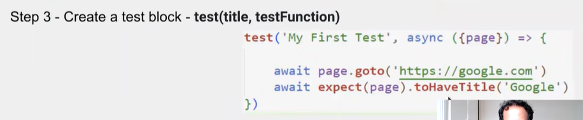
- If browser test ({page})
Page.goto for vist ing the url
- 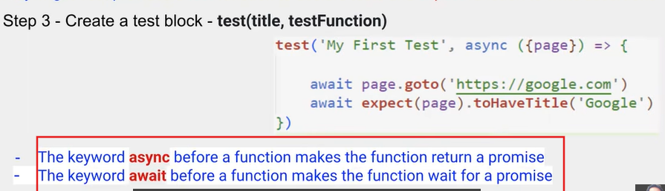
- What is promise
A Promise in JavaScript is an object that represents the eventual result of an asynchronous operation. It lets you write asynchronous code in a cleaner, more readable way than nested callbacks.
Promise States
A Promise has three possible states:
- Pending – The operation is still in progress.
- Fulfilled (Resolved) – The operation completed successfully.
- Rejected – The operation failed.
Pending
|
+----> Fulfilled (Success)
|
+----> Rejected (Failure)
const myPromise = new Promise((resolve, reject) => {
let success = true;

if (success) {
resolve("Operation successful!");
} else {
reject("Something went wrong!");
}
});

Consuming a Promise
Use .then() for success and .catch() for errors.

myPromise
.then(result => {
console.log(result);
})
.catch(error => {
console.log(error);
});

Example with setTimeout
const fetchData = new Promise((resolve, reject) => {
setTimeout(() => {
resolve("Data received");
}, 2000);
});

fetchData.then(data => console.log(data));

Summary
- A Promise represents the future result of an asynchronous operation.
- It has three states: Pending, Fulfilled, and Rejected.
- Use .then() to handle success, .catch() for errors, and .finally() for cleanup.
- Use async/await for cleaner asynchronous code.
- Promises help avoid "callback hell" and make asynchronous JavaScript easier to write, read, and maintain.

Here:
- Promise → creates a promise
- resolve() → says "Success! Here is the result."
- reject() → says "Sorry, something went wrong."
- setTimeout() → simulates something taking time
We can get the result using .then():

Request data from server
↓
Promise
↓
Waiting...
↓
┌──────┴──────┐
↓ ↓
Success Failure
resolve() reject()

- Main
- Yes. If you're learning JavaScript for Playwright, you will frequently see:
- await functionName.methodName();
- But there is no single list of all await function.____() methods, because the available methods depend on the object (page, locator, request, etc.).
- Here is the important Playwright list you should learn.
- 1. page methods
- await page.goto();
- await page.reload();
- await page.goBack();
- await page.goForward();
- await page.waitForTimeout();
- await page.waitForLoadState();
- await page.waitForURL();
- await page.waitForSelector();

- await page.title();
- await page.url();

- await page.screenshot();
- await page.pdf();

- await page.close();
- 2. locator methods — VERY IMPORTANT
- Usually you'll write:
- const button = page.locator("#login");
- Then:
- await button.click();
- await button.fill();
- await button.press();
- await button.check();
- await button.uncheck();
- await button.selectOption();
- await button.hover();
- await button.focus();
- await button.blur();

- await button.getAttribute();
- await button.textContent();
- await button.innerText();
- await button.inputValue();

- await button.screenshot();
- await button.scrollIntoViewIfNeeded();

- await button.waitFor();
- For example:
- await page.locator("#username").fill("jishnu");
- await page.locator("#password").fill("12345");
- await page.locator("#login").click();
- 3. expect() assertions
- These are extremely important in testing:
- await expect(page).toHaveTitle();
- await expect(page).toHaveURL();

- await expect(locator).toBeVisible();
- await expect(locator).toBeHidden();
- await expect(locator).toBeEnabled();
- await expect(locator).toBeDisabled();
- await expect(locator).toBeChecked();
- await expect(locator).toBeEditable();

- await expect(locator).toHaveText();
- await expect(locator).toContainText();
- await expect(locator).toHaveValue();
- await expect(locator).toHaveAttribute();
- await expect(locator).toHaveClass();
- Example:
- await expect(page).toHaveTitle("Login Page");

- await expect(page.locator("#login")).toBeVisible();

- await expect(page.locator("#username")).toHaveValue("jishnu");
- 4. Browser methods
- const browser = await chromium.launch();

- const context = await browser.newContext();

- const page = await context.newPage();

- await browser.close();
- await context.close();
- await page.close();
- 5. API testing methods
- When using Playwright API testing:
- const response = await request.get();
- const response = await request.post();
- const response = await request.put();
- const response = await request.patch();
- const response = await request.delete();

- await response.json();
- await response.text();
- await response.body();
- 6. Common waitFor...() methods
- These are worth learning:
- await page.waitForURL();
- await page.waitForLoadState();
- await page.waitForSelector();

- await locator.waitFor();

- await page.waitForTimeout();
- ⭐ Most important for you
- Since you're learning Playwright + JavaScript/TypeScript, don't try to memorize everything at once.
- Start with these:
- await page.goto();

- await page.locator().click();
- await page.locator().fill();
- await page.locator().check();
- await page.locator().selectOption();

- await page.waitForURL();
- await page.waitForLoadState();

- await expect(page).toHaveTitle();
- await expect(page).toHaveURL();
- await expect(locator).toBeVisible();
- await expect(locator).toHaveText();
- await expect(locator).toHaveValue();
- A very useful way to remember it is:
- PAGE
- ├── goto()
- ├── reload()
- ├── goBack()
- ├── goForward()
- ├── title()
- ├── url()
- └── waitFor...()

- LOCATOR
- ├── click()
- ├── fill()
- ├── press()
- ├── check()
- ├── uncheck()
- ├── selectOption()
- ├── hover()
- ├── textContent()
- └── inputValue()

- EXPECT
- ├── toBeVisible()
- ├── toBeHidden()
- ├── toBeEnabled()
- ├── toHaveText()
- ├── toContainText()
- ├── toHaveValue()
- ├── toHaveAttribute()
- ├── toHaveTitle()
- └── toHaveURL()
- Important: await does not mean every JavaScript function needs await. You normally use it when the function returns a Promise. Playwright has many Promise-returning methods, which is why you see await so frequently.

163
.
––––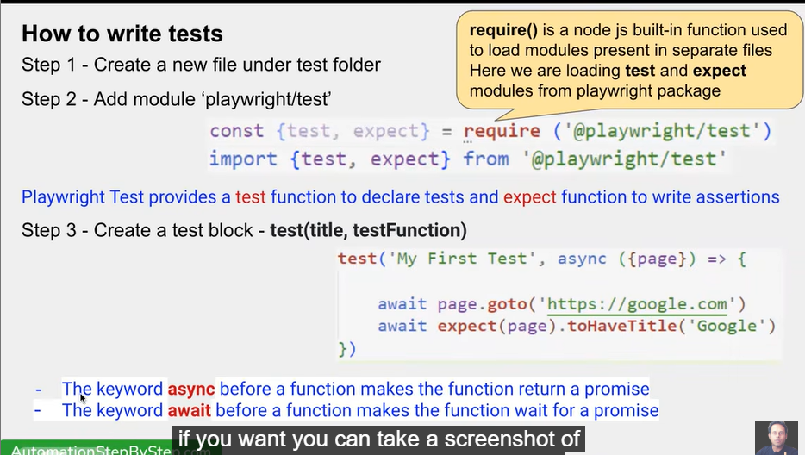
await page.someAction();
await expect(page).toSomething(...)

Recording
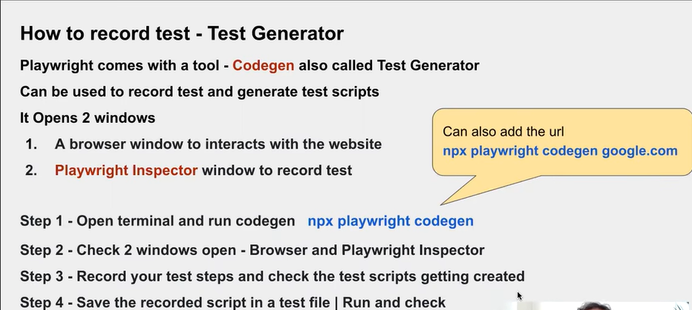

Record the testing
